Whose Plane Is It Anyway?
Game Design Document

By:

Jeremy Thomas and Ryan Sweeny

Table of Contents

- Intro: Page 3
- Plot: Page 3
- Character Bios:
  - Tyrone: Page 4
  - A-Rab: Page 5
  - Red-Dog: Page 6
  - Andrew Weiner: Page 7
  - Milt: Page 8
  - Matthew White: Page 9
  - Jamuel Saxon: Page 10
  - Johnny Alpha: Page 11
  - Cletus O’Doyle: Page 12
  - Chandler Campany: Page 13
- Game Overview: Page 14
- Game Description: Page 14
- Artistic Style Outline: Page 16
- Systematic Breakdown:
- Asset Breakdown
  - Art Assets: Page 17
  - Text Assets: Page 18
  - Sound Assets: Page 18
- Marketing Strategy: Page 19
- Problems Encountered in Development: Page 19
- Planned Future Editions: Page 20
- Screenshots:
  - Figure A- Title Screen: Page 21
  - Figure B- Tutorial: Page 22
  - Figure C- Cut scene: Page 23
  - Figure D- Character Selection Menu: Page 24
  - Figure E- Game GUI: Page 25

Intro:
Descending out of control, Flight 69 needs a savior. That savior happens to be one of multiple characters who have trouble operating a toilet, much less a rapidly careening passenger plane. These characters all have everything to gain from saving the plane, and will stop at no bounds to achieve that glory; even if it means beating the Hell out of each other. Whose Plane Is It Anyway? is a 2D party game that stars some of what you would call “America’s Finest.”
Plot:
After working your way through airport security and the oddly thorough full-cavity search from the TSA agents, you make your way to your plane and find your seat aboard Flight 69. Mid-flight, you notice the flight attendants becoming increasingly panicked, and wonder what could be happening. Finally, someone comes over the intercom and informs everyone of the situation. It appears that both the pilot and co-pilot have both died from heart attacks...at the same time. Panic erupts, as everyone is certain that this will be their final flight. Fortunately, there are four people on the plane who decide to step up and save the day. Unfortunately, each person has some sort of mental handicap, and will be relying on pure will-power. Making matters worse, nobody really knows how to fly a plane. In order to figure out how to live, you must search for the pages of the flight manual, cleverly hidden by the TSA throughout the plane in an attempt to prevent terrorist hijackings. Will Flight 69 return home safely? Who will save the day? And...whose plane is it, anyway?

Character Bios:
Name: Tyrone-The Air Marshal
Piece:
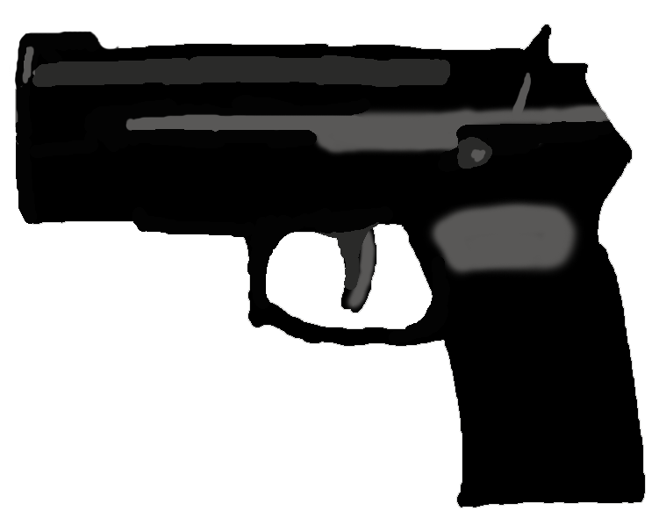
Story: After an unsuccessful stint as a mall cop, Paul Blart changed his name to Tyrone, and scored a gig as an air marshal. That’s basically all that’s changed though. Life as an air marshal is just way too active for his laid back lifestyle of sitting and eating doughnuts. The ensuing chaos on Flight 69 screams “desk job promotion”, and he will not let anyone stand between him and his dream job.

Name: A-rab the Arab
Piece:
Story: A peaceful man, A-rab has never agreed with any acts of violence between the U.S and the Middle East, and has always encouraged peace talks. So, when the pandemonium aboard Flight 69 erupts, he sees it as a way for people to see him in a good light. However, in his attempts to reach the cockpit the other passengers believe that he is a terrorist and some believe that he is responsible for the pilots deaths, and they will do anything they can to stop him.

Name: Red-Dog
Piece:
Story: All Red-Dog would like in his life is to not face a life-threatening crisis for just one moment. Stricken with PTSD after being captured and detained in a Vietcong internment camp, he is instantly thrown back into the war when all chaos breaks loose on Flight 69. He will fight his way through the “’Cong” in order to save the plane.

Name: Andrew Weiner
Piece:
Story: Suffering from the recent “Weinergate” scandal, he is looking for any way he can to find to win an upcoming election. His luck has finally changed when he boards upon Flight 69, and finds out that both pilots have died. He is willing to do anything to come out on top as a real American hero.

Name: Milt
Piece:
Story: Life is usually a great time when you can’t remember last night, or the night before or the night before that or when everything in between parties is simply “small unimportant details.” By that logic, Milt’s life is pretty grand, until he boarded Flight 69. Hung-over as hell, his headache is pounding from all the chaos, which he swears his life to put an end to.

Name: Mathew White
Piece:
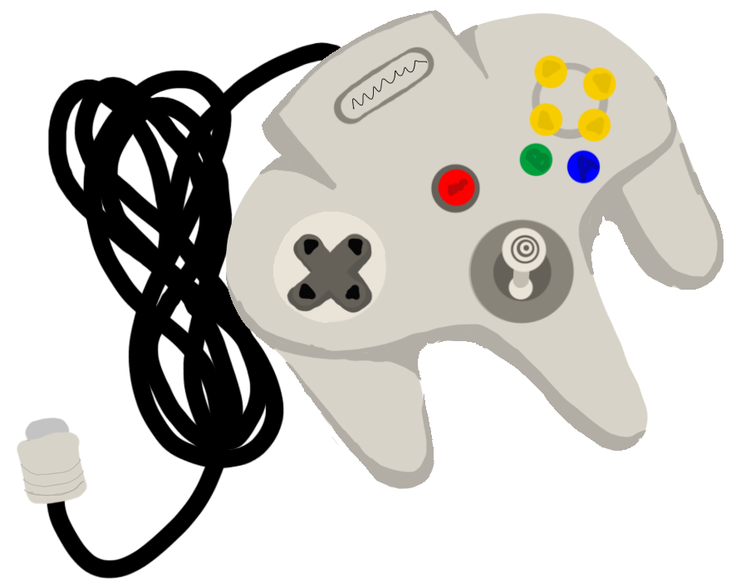
Story: Stuck in a fantasy, this 26 year old Canadian still lives in his parent’s basement. Known for playing video games he has decided to act like one of his favorite heroes. As Flight 69’s chaos ensues, he decides to fight through the mobs as Link to get to the princess Zelda who is stuck in the twilight cockpit. As far as he is concerned no one will stand in his way to save the princess.

Name: Jamuel L Saxon
Piece:
Story: On his return flight from the movie set of “Snakes in my plane”, Jamuel L Saxon wakes up in the ensuing chaos of Flight 69. He believes that he is still on the set of his movie and is convinced for some reason somehow snakes are responsible. Very protective of his spot of lead role, he will forcefully and obscenely take down any “extras” in his way.

Name: Johnny Alpha
Piece:
Story: Waiting in line at airport security, Johnny Alpha injects the remaining four gallons of his steroids straight into his ass. He reassures the TSA agent that “It’s not gay, I’m building mass” and then proceeds to ask him “Do you even lift bro? I lift 55 pounds! 1v1 bro, I’ll wreck you!” On his way to the Mr. Universe pageant, Johnny is willing to do whatever it takes to add on any muscle he can. When the poo hits the oscillator on Flight 69, his roid rage kicks in. Viewing this as an extra workout, Johnny is itching to fight anybody he can while saving his god-like body.

Name: Cletus O’Doyle
Piece:
Story: On a transfer flight to Alaska, in an attempt to stay as far away from sunlight as possible, Cletus is hoping to mind his own business and avoid being made fun of for being an evil ginger child that has no soul. However, that idea is blown to pieces when Flight 69 turns into a flight from hell. Seeing an opportunity to prove that gingers DO in fact have souls, as well as feeling his short temper building up, Cletus is ready to take out his anger on any bully that gets in his way.
Name: Chandler Campany
Piece:
Story: Chandler is a strong, independent, short woman that don’t need no man in her life. Literally, she plays for both teams…..cheater. Convinced that all of the men on the plane are incompetent, bumbling idiots that are incapable of doing much more than beating each other to a pulp, she views herself as Flight 69’s only hope for survival.

Game Overview:
The flight that you just so happen to be fortunate enough to board is crashing, and only a few of America’s most mentally handicapped citizens are brave enough to stop it. The players roll a die to determine how many spaces they get to move around the board, and try to collect Flight Manual pages hidden among the plane. The more Flight Manual pages a player possesses, the more luck they will have in trying to save the plane. In their quest to find these pages, the player may run into other events that may or may not be beneficial to them, such as rolling again or being sent back to the start. A player can save the plane by having at least one Flight Manual page, entering the cockpit, and rolling a one or a six.
The amount of times they get to roll is proportional to how many Flight Manual pages they possess (i.e. a player gets to roll six times if they have six Flight Manual pages, five times if they have five pages, etc.). If the player fails to save the plane, their pages are placed back into the deck, the player is sent back to the start, and the amount of tries to save the plane is reduced by one. Players can only try to save the plane three times overall; if all three attempts are exhausted with no success, the plane crashes and everyone dies (a plane isn’t going to fly itself forever, you know).
Gameplay Description:
Each player will begin each turn by rolling the dice to determine how many spaces they move ahead. Players are only allowed to move the carpeted aisle spaces, event spaces (designated by a large exclamation mark on top of the tile), and pink cockpit entrance spaces. The seat spaces are off limits. If the player lands on an event space after rolling the dice, they “draw” a card from the top of the event card pile, and the instructions on the card determines what happens to that player. If a “Flight Manual Page” card is picked up, the player keeps it for future use. If a player lands on the same space as another player, they have a “duel.” Both players duel by clicking the die icon to roll their die, and whoever rolls the highest number wins. A tie results in a re-roll. The losing player forfeits all of their Pages to the winning player (if they have any), and then moves back to their starting space. If both players land on the same event space, both players duel as normal. If the player who most recently landed on the event space wins the duel, he/she draws an event card. However, if the player who was originally on the event space wins the duel, they do NOT draw an event card from the deck.
In order for a player to enter the cockpit, they must first possess at least one page. A player does not have to perfectly land on the pink spaces either, they may stop mid-move. This option is available to all players, whether they have pages or not, and to perform this action the player clicks a button on the top of the GUI that is normally disabled until a situation such as this. However, a player must have at least one Flight Manual page before they can enter the cockpit and attempt a victory. When in the cockpit, the player must roll either a one or a six. A player may get multiple chances at this, as the number of times they may roll is equal to the number of pages they have. For example, if a player has three pages, they may roll the dice three times. In any of those three rolls, if they roll a one of a six, they win! Yay! However, if they do not win, they must forfeit their pages to the event deck (with the deck being thoroughly shuffled after) and return to their starting point. If, after three total attempts, the game is not won, the plane crashes into a mountain and the game is over; nobody wins.
Artistic Style Outline
The Title Screen (Screenshots-Figure A) shows a plane flying across the vast blue sky, soaring past puffy white clouds. Underneath this, three options are displayed: Start Game, Tutorial, and Exit. Upon clicking the start button, you will be brought to an introduction cut scene, where the plot is explained (Screenshots-Figure B). Once this cut scene finishes or the user chooses to skip it, the character selection screen is displayed (Screenshots-Figure C). The right side of the screen has a panel that will display additional character information.
The main game GUI (Screenshots-Figure D) is made up of the main game board, a player-specific panel across the top of the screen, and a general game play panel on the right side of the screen. The individual spaces of the board consist of normal game play spaces, event spaces, and cockpit entrance spaces. When the die in the game play panel is clicked, a roll animation is played. The pieces will move according to how the players decide to move them. The duel scene (Screenshots-Figure F separate paper) is shown by an animation announcing the sequence, followed by each player’s icons appearing on opposite sides of the screen. Under each icon is a game die. Upon clicking the die, the roll animation is played. The winning character is announced, and the sequence is ended. The cockpit challenge scene (Screenshots-Figure G separate paper) is similar, except only one player icon is displayed with the number of pages (rolls) remaining also displayed. The die below the player’s icon is rolled when clicked.

Systematic Breakdown
The game is coded in Java, making extensive use of the default Swing library. There is no save/load system, mainly because the game is intended to be very fast-paced with most games never exceeding 30 minutes. The Swing library makes it easy and quick to render the GUI and game play, which was the main reason we decided to use it. The game is developed with the NetBeans IDE with no other external game libraries used in development.
Asset Breakdown
Art assets:
- Floor tile image
- Chair tile image
- Event tile image
- Cockpit entry tile image
- Cockpit tile image (same as Event tile)
- Dice/dice rolling animations
- Character board tokens
- Character selection pictures/tokens
- Plane-Menu Background
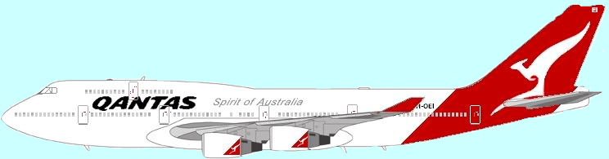
- Cloud-Menu Background

Text assets:
- Tutorial/instructions
- Storyline scene
- Card drawing
- Credits

Sound assets:
N/A
Marketing Strategy:
We plan to market this game as a general multiplayer game intended to be played at parties with friends. The age range would be 15+. Right now, we are currently releasing this game as a work-in-progress open beta. Although the beta currently does not support online play, as progress is made, we do plan on supporting online multiplayer. We also plan to add in an AI component so that players who have no friends or are very shy around strangers can play a complete game against a computer. We are offering the current version of the program for free as a download, however once we progress beyond the open beta stage we will price it at approximately $5.

Problems Encountered in Development:
Many of our original ideas had to be cut to make the open beta release deadline. We do plan on developing these ideas further in hopes that they do make the final version.

Here is a list of different things that were cut due to time constraints:
- Music
- AI
- Movement quality (we currently have a temporary player movement engine)
- Timers/Difficulty modes
- Some event types
- A full tutorial
Planned Future Additions:
As the version released is only in the Beta stage, we plan on releasing further, updated versions of the game. Possible included features:
- All aspects in above section
- Multiplayer mode
- Additional characters
- Improved game engine

Screenshots:
Figure A- Title Screen
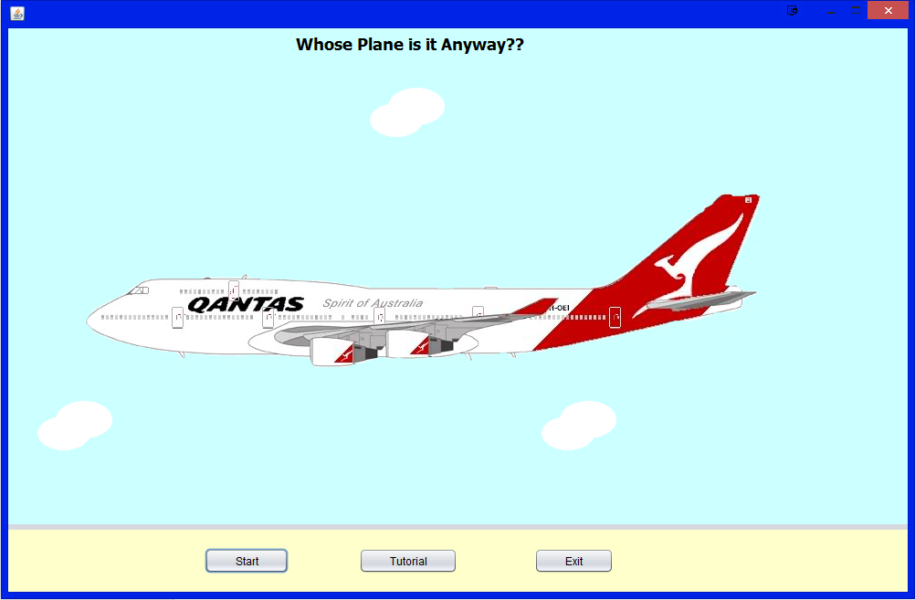

Figure B- Tutorial
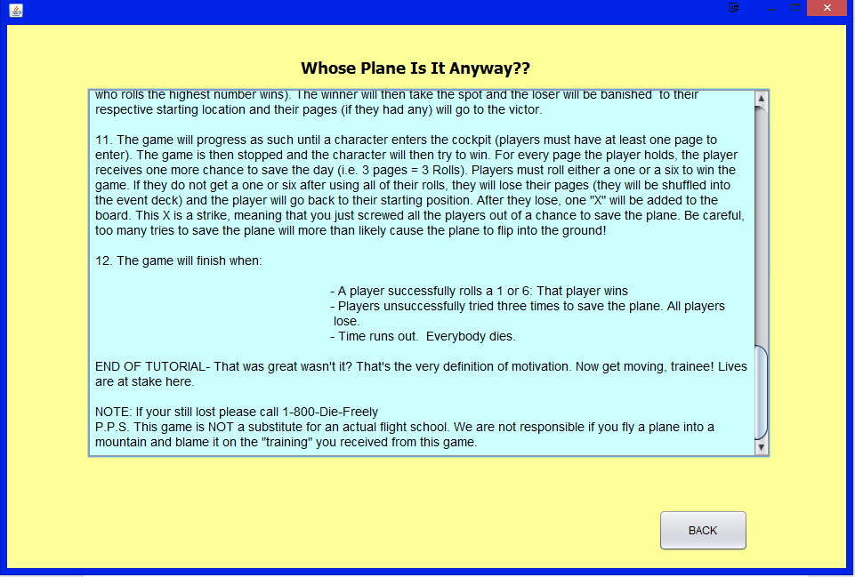

Figure C- Cut scene
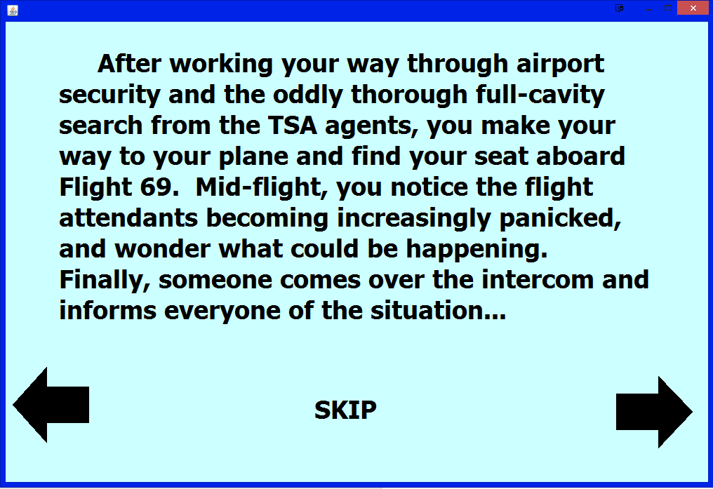

Figure D- Character Selection Menu
